AS question to AI: "How to use a microphone designed for random incidence as a free-field mic?" [Note: the usage case specified]
​
AI answer:​
​
# Using a Random Incidence Microphone as a Free-Field Microphone​
​
If you have a microphone that is designed for random incidence (diffuse field) and you want to use it as a free-field (directional, single-front-source) microphone, there are important considerations. In most cases, you can’t perfectly convert its response, but you can mitigate errors with compensation and proper usage. Here’s a practical guide.​
​
## Key concepts​
​
- **Random incidence (diffuse field) microphone**: Calibrated so that its response is uniform to sound arriving from all directions. Its frequency response typically includes a roll-off or coloration that accounts for oblique incidence. (AS emphasis)​
- **Free-field microphone**: Calibrated to respond to sound coming from one dominant direction (usually front-facing). It has a different directional response and a correction curve for the on-axis response.​
​
## When you can use a random incidence mic as a free-field mic​
​
- If the microphone has a well-documented, invertible on-axis frequency response and you can apply the manufacturer’s free-field correction, you can approximate free-field measurements.​
- If you only need rough measurements and are aware of the added uncertainty, you can proceed with caution.​
​
........​
​
AS ... "Surely the random incidence mic does not have an HF roll-off?…."
​
# Reassessing the on-axis HF boost in a random-incidence microphone​
​
You're observing a rising high-frequency (HF) response on-axis in a free-field measurement with a random-incidence (diffuse-field) mic. [AS is saying the opposite]. You’re seeing a boost, not a roll-off, when compared to a free-field mic. [Yes, correct]. Here’s how to reconcile this and what it means for measurement and correction.​
​
## Key points to align with your observation​
​
- **Random-incidence mic design goal**: Flat response in a diffuse field (sound arriving from all directions with the appropriate angular weighting).​
- **On-axis in free field (your measurement condition)**: The random-incidence mic often shows a relative HF boost on-axis compared with a free-field-calibrated mic, because:​
- The RI mic’s on-axis pressure response is designed to be higher at HF to compensate for the loss of energy from oblique incidence in a diffuse field.​
- In a pure free-field, single-direction excitation, there is no averaging over angles, so the HI boost manifests as an apparent HF rise when you compare to a free-field mic whose on-axis response is flatter or rolled off less.​
​
- **Interpretation**: The boost you see is not a misbehaviour; it is the expected on-axis characteristic of a random-incidence mic when evaluated in a free-field reference. The diffuse-field calibration relies on this HF boost to yield a flat response when averaged over directions.​
​
================​
​
Snapped the AI background process as it tried to reconcile these opposing positions. Note: was not possible to copy the text.
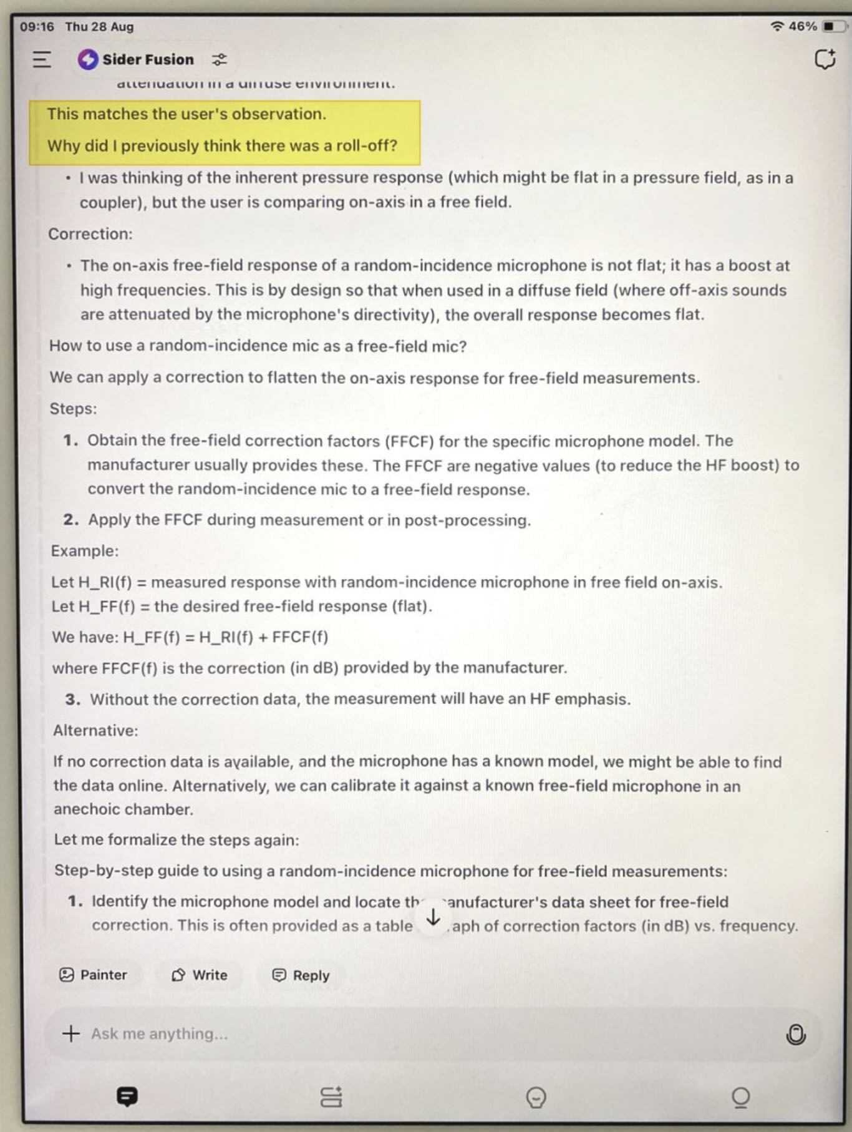

So the assumptions that AI was making needed to be challenged.
Incidentally, the maker's data sheet clearly shows the correction needed to adapt the frequency response of a random incidence microphone for use as a free-field mic:
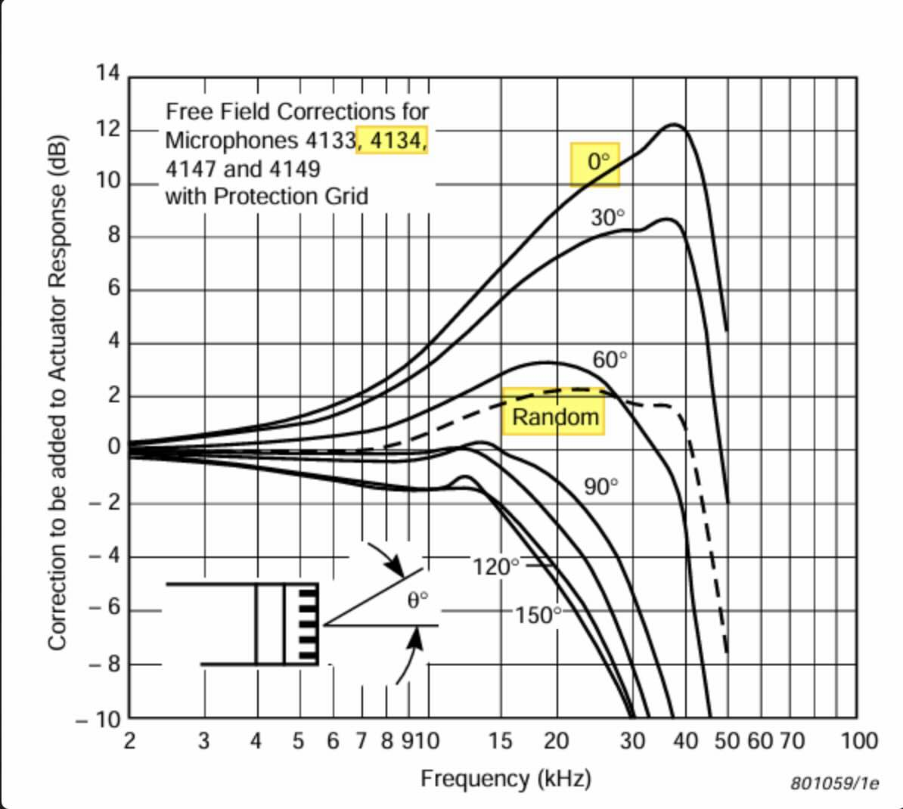
This clearly shows that the random-incidence mic, when used in a free-field has a very substantial HF boost when pointed directly at the source (0º) which would need to be allowed for (compensated for) if a free-field microphone was not available.
Alan Shaw
Designer, owner
Harbeth Audio UK

